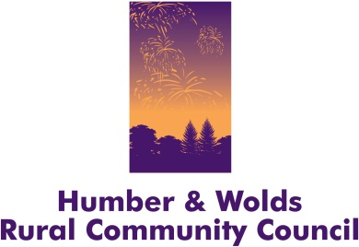
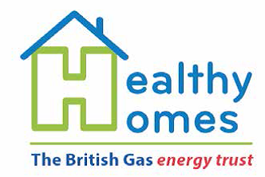

Humber Wolds Rural Community Council is working across East Yorkshire in partnership with East Riding of Yorkshire Council to tackle the issue of rural residents with existing health conditions that are made worse by living in cold homes.
The new initiative called the ‘Healthy Homes Project” is funded by the British Gas Energy Trust. Humber & Wolds Rural Community Council (HWRCC) is co-ordinating a united effort with the local authority and voluntary & community sector groups, carers associations, home improvement agencies, health professionals and others to focus on improving winter health, energy efficiency, warming cold homes and providing emergency support. This will address the root causes of cold homes and its effect on those living with health conditions.
Susan Oliver, Delivery and Development Manager at Humber & Wolds Rural Community Council, said: “By working together with other organisations across the public and charity sector, we can address such difficult issues as fuel poverty, emergency hospital admissions, poor health and well-being, and at its most severe – excess winter deaths.
“Living in a cold home is not only detrimental to physical health, but it also affects emotional wellbeing, and can lead to loneliness or low confidence, or to mental health issues like depression.
“Through a range of services within the Healthy Homes Project, we will be able to face these challenges head-on and ensure that as many people as possible have a warmer home and are well-cared for throughout the year and especially during the long, cold winter months.”
The project is particularly targeting families with young children and the elderly who live in a low income, high fuel cost household as they are the most vulnerable groups. The statistics below show some of the issues that can be tackled by the project:
Fuel poverty affects over 11,900 households in the East Riding of Yorkshire and was a contributing factor to the 4,100 excess winter deaths in the winter of 2014/15 in Yorkshire & the Humber. In addition, some 108,000 children are believed to live in fuel poor households across Yorkshire & the Humber, making them vulnerable to ill health. (2013 stats)
Referrals can be made directly to HWRCC by anyone, at any time including all of the following:

- Rural residents who live in cold homes and have an existing health condition that is made worse by the lack of heat in their home. (The Client Group)
- Carers, Friends, Family and Neighbours of the above
- Health and Social Care professionals who visit the client group, including GPs.
- Frontline staff from statutory agencies who visit or have contact with the client group.
- Voluntary and Community Sector organisations
- Local community groups
- Local Energy Champions, who are part of the Healthy Homes Project
- Town & Parish Councillors and Ward Councillors
- Ministers of the Church
The project will support people who live in rural areas where houses are often off the mains gas grid, rely on expensive forms of fuel to heat their homes, are poorly-insulated and even cut off when bad weather strikes.
Support and aid will be wide-ranging and tailored depending on individual needs, including providing basic energy-saving advice, conducting home visits to identify cold related issues, providing debt and benefit advice, installing Renewable Heating systems in eligible homes, offering one off help with Oil, LPG and coal where no heating can be afforded, and applying for Warm Homes Discounts and registering vulnerable individuals for the Priority Services Register. As the project is fully funded, all the help we can give is free at the point of delivery.
The project has the use of a Thermal Imaging Camera. This will be used to take a thermal image of a client’s dwelling before and after any of the measures have been implemented, to show if improvements in heat retention have been made.
Working across 69 rural communities in East Yorkshire, the Healthy Homes Project will work in these settlements from January to the end of March 2017. Full details of the areas to be covered and the individual villages can be seen on the website at www.hwrcc.org.uk
For more information on the project contact Peter Hirschfeld on 01652 637700 or email peter.hirschfeld@hwrcc.org.uk or info@hwrcc.org.uk
Humber & Wolds Rural Community Council
Registrar’s Office, Baysgarth House, Caistor Road, Barton upon Humber DN18 6AH
Registered Charity No 1099439 Company No. 4606085

