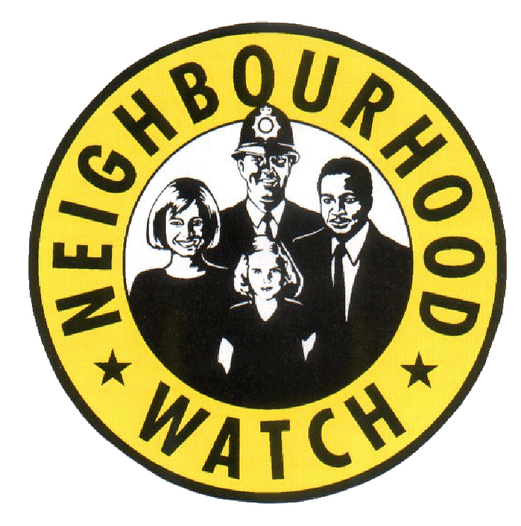

EAST RIDING NEIGHBOURHOOD WATCH

July 2018

New Police Communications System: MY COMMUNITY ALERT

“Humberside Police have launched a new communication system that enables residents, businesses and community groups to find out what is happening in their local area.

The new system, called My Community Alert, allows you to register and receive real time messages about incidents happening in your neighbourhood that may affect you and your neighbours.

Choose how you would like to receive messages - by text, voicemail or email – and how often you would like to receive alerts.

For more details go to the Humberside Police Website or contact your local Community Policing Team”

https://www.humberside.police.uk/campaign/my-community-alert

Information provided by East Riding Safeguarding Children Board - Together We Can Tackle Child Abuse

“We all have a role to play in protecting children and young people from child abuse and neglect. But right now, some people do not report their concerns because they’re not certain of the signs, don’t know where to report, or are worried about being wrong. This means that East Riding Council could be missing out on vital information they need to keep children safe from harm. The following links provide more information about signs to spot and how to report, so that children and young people at risk get the help they need more quickly:
https://tacklechildabuse.campaign.gov.uk/

Together We Can Tackle Child Abuse Dept of Education Campaign
www.erscb.org.uk Worried about a young person? Call 01482 395500
•All children have a right to be safe and should be protected from all forms of abuse and neglect.
•Anything you notice can help a child at risk. We all have a role to play in protecting children and young people from child abuse and neglect.
•Last year nearly 400,000 children in England were supported because someone noticed they needed help.
•To help protect a child or young person look out for changes in their Appearance, Behaviour and Communication (A B C).
•It’s up to all of us to keep children safe. Many people do not act because they’re worried about being wrong. You don’t have to be absolutely certain; if you’re concerned a child is being abused, their safety is at risk and/or you genuinely believe or strongly suspect there is drug use at a property at which a child resides, speak to someone.
•Information is gathered from many sources, and your report forms part of a bigger picture. Reporting your concerns could provide the missing piece of information that is needed to keep a child safe.
If you think it, report it.”

EHaSH REFERRALS
“Any allegations should be forwarded to EHaSH (Early Help and Safeguarding Hub)
Call 01482 395500”

Sent from PCCs Engagement Officer, Debbie Fagan – Community Recovery Officers

“Community Recovery Officers go out into the community after an incident and gather information from residents providing a face and a point of contact for people to interact with the Council.
CROs may be asked to door knock or to hand out information to people at community events/meetings. It may just be a case of being present in and around an area. It really depends on the incident and what the Recovery Manager is requesting.
For more details contact Rebecca Johns-Bielby
Emergency Planning Officer Humber Emergency Planning Service HF12 County Hall Beverley HU17 9BA
Tel: 01482 393058”

Sent from PCCs Engagement Officer Debbie - Shredder Scheme
“You may or may not already have heard about the Shredder scheme in North East Lincs. The NHW lead has been awarded funding from their Crime Reduction Fund for the purchase of 2 Industrial ‘cross cutting’ Shredders which are placed in accessible buildings in North East Lincs for the Public to use to safely dispose of confidential papers such as old bank statements etc. thereby reducing the risk of fraud etc. The paper can then be recycled.

If you would like more information on the shredder scheme please contact Maureen Yates.”

Sent from - Humberside Police and The Police and Crime Commissioner’s Office - CRIMESTOPPERS

If you do not have direct contact with your local police community officers and you have information of criminal activity that you would like to share anonymously then please use crime stoppers 0800 555 111

SCAM WARNINGS
You are always advised not to click on links or to give personal information in response to emails or cold callers. Here are a few recent scams that have come through from NHW Coordinators.

“A resident has just received an automated phone call from their ‘ service provider’ saying that their computer’s IPS address has been compromised. There is then a menu of numbers to press to be connected to resolve the problem. This is obviously a scam and to be ignored as KCom wouldn’t use such a method. Can you send out a warning to tell everyone to ignore, please”

“There is an email circulating supposedly from Santander, alerting people that a password has been input more than three times. There is a link on the email to click, which presumably will then lead to a page requesting your details be entered. The email is clearly not legitimate. The spelling and grammar is not that of what you would expect from Santander! The graphics are, however quite convincing and if you were to just glance at it, the reader may be fooled into clicking the link! This has been reported to Santander.”
NOTE: The new Police Alert System also sends useful information and scam warnings that come directly from Action Fraud so if you would like to link up then use the information in the earlier part of this newsletter”

“Today we have received 3 phone calls, purportedly from BT, informing us that there is a problem with our internet connection, and advising us to press 1, for this, or 2 for that etc. The calls were all from an English landline, all different numbers, and were a recorded message by a female with an American accent.
We reported this to BT who said they would look into it.
We just wanted to remind others to be wary of strange phone calls asking us to press numbers. It is particularly ironic that they should target households in this area, to whom BT telephones are not available”

And finally…Crime Prevention Shop
A reminder that Hull Neighbourhood Networks have an on line shop where you can buy all sorts of crime prevention items.
Here’s the link
https://www.nnetwork.org.uk/shop/

There are a number of items available including card protectors which will stop fraud by blocking access to the magnetic strip on your card which if accessed can result in your card details being duplicated.
we sell them at a £1.00 each!

The coupon code is ERMEMBER so that the groups in the East Riding can get the discount. Just add the coupon code when prompted and the discount will be taken off,
The current discount is £1.00 per item and currently £5.00 off the cycle lock. We have set up postage with Hermes but they can offer collection from their base at Zeal’s Garth Hull free of charge.

Maureen Yates Community and Crime Reduction Resilience Officer
Housing and Public Protection, East Riding of Yorkshire Council, County Hall, Cross Street, Beverley
HU17 9BA

