Pocklington Provincial Update for July 2015.
1. Priority
Issue: Pocklington Town Centre area (Evenings):

Throughout July, we are to continue our High Visibility patrols of the Pocklington Town Centre area to deter potential anti-social behaviour. These patrols include regular checks on peripheral areas at Pocklington Infants’ School, Maxwell Road (periodic reports of criminal damage and youths causing annoyance), Broadmanor Play Park (periodic reports of anti-social behaviour on an evening), Waterloo Lane (reports of low level anti-social behaviour and criminal damage), All Saints Church yard (reports of periodic anti-social behaviour), and Union Street (reports of criminal damage).

In addition, recent complaints of youths causing annoyance with vehicles on the Station Road car park will result in this location being targeted and consideration made of offences under Section 59 of the Police Act, which can result in vehicles being used to cause harassment, alarm or distress being seized.

Criminal offenders will be challenged robustly, arrested or reported for summons. Penalty Notices for Disorder or warning letters may be used in appropriate cases however, those who offend should expect to be arrested and dealt with if their anti social behaviour amounts to criminal offending. The exercise of discretion should not be expected.

2 Priority
Issue: Youths causing damage / annoyance with Vehicles, Stamford Bridge (Evenings):

Following reports of anti-social behaviour by groups of youths congregating with vehicles in the vicinity of the Viking Road car park on an evening, Patrols will be regularly checking this location during July. Consideration will be given to the issue of £90 Penalty Notices for Disorder and arrest where appropriate, in addition to lower level offenders being dealt with under the FAIRWAY process jointly with East Riding of Yorkshire Council. It is unlikely that any discretion will be shown. Drivers using their cars to cause alarm or distress will be considered for warnings and possible seizure of their vehicles under Section 59 of the Police Reform Act.

3. Priority
Issue: Youths Causing Annoyance, area of Sherbuttgate, Pocklington (Evenings):
Officers will continue to patrol the area regularly throughout July.

4. Meetings

Street Patrol in Wilberfoss
PCSO Gareth Ludlow will be patrolling around Wilberfoss from 8:30am to 9:30am on the 13th July.

Police “Drop In surgery” at Lob Lane Sheltered Housing Coffee Morning, Stamford Bridge:
PCSO Gareth Ludlow has arranged a Drop In Surgery from 09:30 -11:00 at the above location to discuss community issues and offer crime prevention advice on the 28th August 2015.

5. Crimes in your area

- A car parked on the road outside the owners property in Pocklington was damaged as a result of an unknown person/s scratching the full length of one side of the car with a sharp instrument.
- 2 panes of glass of a ground floor window of a property in Pocklington were smashed, entry was not gained.
- A secure garden shed in the Yapham area was broken into and various garden equipment was stolen.
- A mirror of a wing mirror holder on a ford mini bus was stolen.
- Two hanging baskets were stolen from a property.
- A hasp and lock on a wooden gate attached to a side fence of a property in Wilberfoss was damaged.
- Thieves have used large agricultural machinery to steal a cash machine from within a wall at a petrol station near Dunnington.

6. News and Appeals

Bike Security

Theft of bicycles is a real issue. In the UK a bicycle is stolen approximately every minute of the day, perhaps worsened due to the increasing popularity of expensive models, which in turn can be sold far too easily via online auctions. So what can you do to protect your property?

- If you haven’t done so already take a photograph of your bike and retain it just in case. A picture paints a thousand words and provides a ready visual aid to the police if your bike is stolen.

- Invest in a quality “D” lock to help reduce the risk of your bike being stolen.

- Register your bicycles frame number along with any pictures and other details you have on www.immobilise.com. (Registration on immobilise only takes a couple of minutes. All you need is your bike's make, model, identifying number code(s) and a few photographs. Firstly locate the frame number in preparation. The red dots indicate where they're commonly found on a bicycle and then follow the instructions on the immobilise website.)
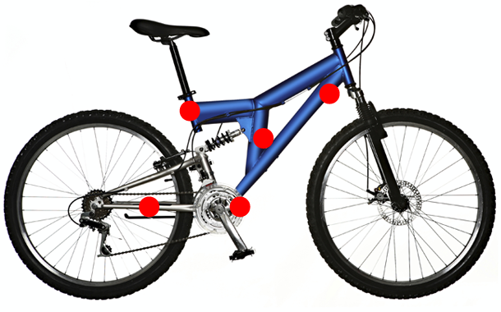

- Look at where you are storing your bike and make sure that your shed or garage is secured with a good quality lock. Many shed windows are never used, if this is the case – why not screw them shut. Fitting mesh or steel bars across the window from the inside allows light to enter but means the thief has to go to a lot of trouble to remove them. Replace broken glass with laminated glass.

- Consider buying a cycle anchor that can be bolted to the wall or floor of your shed which your cycle can then be fastened to or if you have several cycles lock them altogether.
- Keep back gates into your property locked when not in use.
- Security lights can be a great deterrent if your home or garden is secluded from street lighting etc.
- Install lights which come on when it gets dark and switch off when it gets light, or fit motion sensor lights which activate when someone passes.

- Lastly if you are having to leave your bike out on the street, where possible leave it in a well lit area and lock both the frame and wheels to the bike stand. If there is no stand, ensure that its locked to secure street furniture eg railings or a lamp post.

Be aware of Sneak Thieves

Now that summer is here we all want to relax, enjoy the sun, potter around outside and get out in the fresh air to do those little jobs around the house and garden.

However we still need to think about home security to prevent ourselves from becoming victims of crime.

So what do we need to do?

You need to ensure that your home is always secure when you go out and that you don’t leave potential entry points open and accessible on a night when you are asleep, for example a downstairs window or a door. Make it part of your normal routine to check that you have locked all of your doors and windows before either going out or going to bed.

We might be out working in the garden, leaving windows or doors to our homes wide open. We might be out of sight of our open doors or windows, perhaps with a loud lawn mower or power tools going, and it is so easy in these circumstances for a sneak thief to take advantage of the situation, go inside our homes and steal things.

The same applies with our sheds and garages. We open these up to take out the tools that we want, but how often do we leave the doors wide open and go off into the garden leaving everything in them on display to passers by? How easy is it then for someone to take advantage of this situation and steal bikes, power tools or garden equipment!

And then there’s the car to consider: On a warm day, there might be a temptation to leave it parked up on the drive with its windows open to allow fresh air to circulate. But if we’re leaving it unattended, it is easy for someone to take items from it or even to steal it.

In all three of the circumstances there’s the potential to lose valuable property, have your house burgled, or lose your car, especially if your car keys are left on display by an open window, an open back/front door or on a kitchen work top.

The kinds of thefts described are committed by opportunists who could be wandering around your neighbourhood looking to take advantage of people who leave their property insecure. So don’t let the thieves get away with it!

If you get a suspicious person or vehicle in your street, let us know by ringing Humberside Police on 101 (or 999 if there’s a crime in progress). If you can safely do so, get registration numbers or note the description of the person seen and what they are doing. The more information we get, the better we can help you and your community. You may even prevent or help detect a crime!

If you want crime prevention advice, contact your Neighbourhood Policing Team. Our Police Community Support Officers are trained in home security and could help provide you with the information that reduces your chance of being a victim of crime.

Do enjoy the warmer weather, but think security and don’t allow yourself to become a victim of crime.

